AI Brand Operator — Concept Whitepaper
Oct 28, 2026 · @AURELIEN

Executive summary
A subscription platform where a brand plugs in its product and goals, and AI runs its online business end to end, does not exist yet in the UK or EU. Adjacent players are moving fast, so the window is roughly 12 to 24 months.
- Model: brands subscribe; the platform never buys or holds stock, and the brand stays seller of record.
- Gap: competitors either own stock and use large teams (Pattern), cover one channel (Lumian, Amazon's and Shopify's free agents), or one function.
- Wedge: a market-entry autopilot that takes consumer health and beauty brands live on UK and EU marketplaces.
- Next: a 12-week team workplan to answer seven critical questions before building at scale (final section).

The problem
Good products stall because commercial execution is expensive, slow and fragmented.
- Selling online needs many specialists per channel: listings, ads, pricing, stock, logistics, service, compliance and finance.
- Full-service Amazon agencies charge $3,000 to $15,000+ a month or 3% to 15% of sales, usually for one channel (Ecom Brainly).
- Entering a new country adds compliance (for example EU GPSR), localisation and VAT, so many products never leave their home market.

The concept
An AI brand operator: the brand subscribes, sets its goals, and the platform runs the business across every online channel.
- The brand: sets targets, budget, positioning and red lines; ships stock to FBA or a 3PL; approves exceptions.
- The platform: channel set-up, listings, ads, pricing, forecasting, customer service, compliance checks and reporting.
- Asset-light: no stock bought or held; the brand keeps its stock, books and liability.
- Option: live data across brands creates a later option to invest in the best performers.
It sells the work, not the software: companies spend about $6 on services for every $1 on software (Lumian).

How it works
The brand sets goals and ships stock once; an orchestrator then directs specialized agents across every channel, with guardrails and a small expert bench for exceptions.
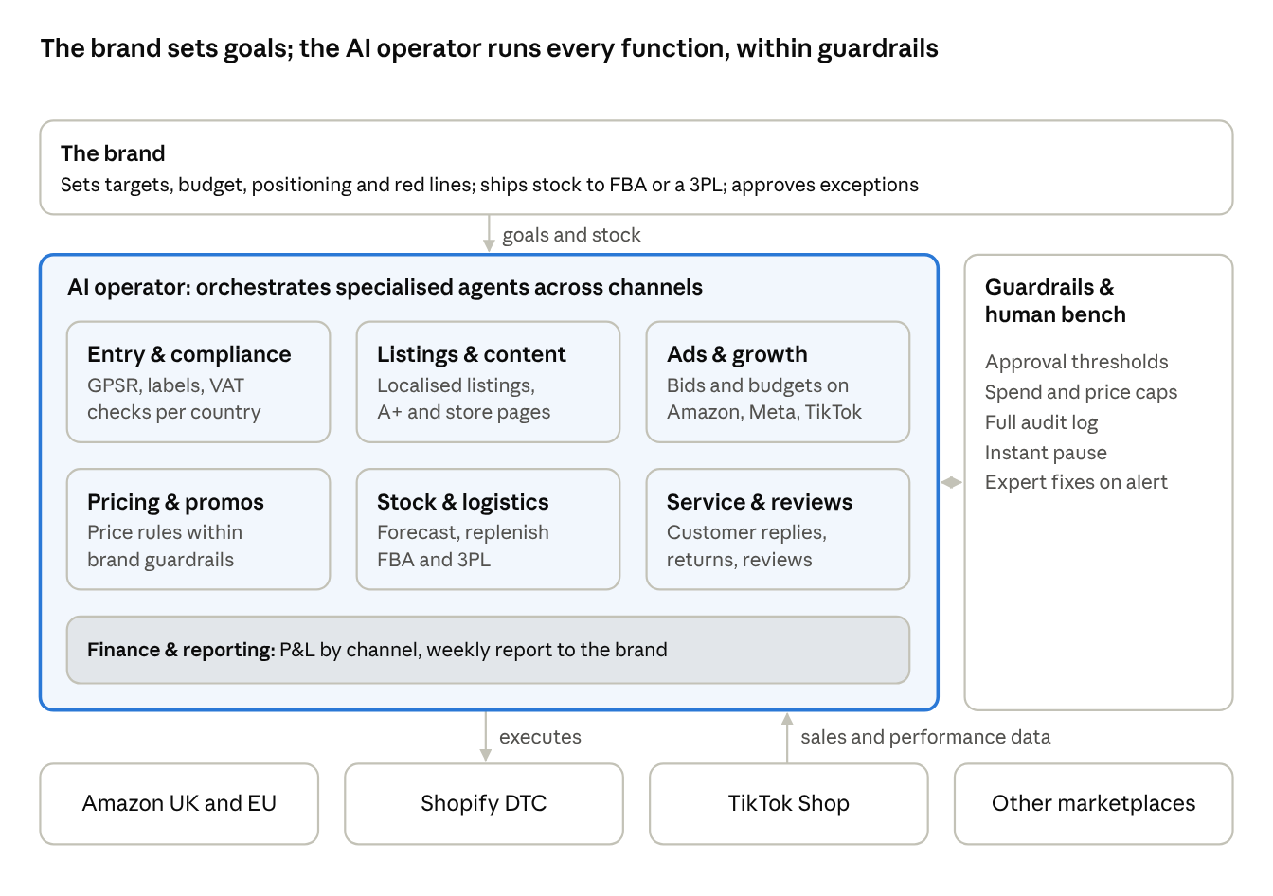
how it works · brand, AI operator, channels
Data flows back from every channel, so agents learn across all brands. Anything outside the brand's guardrails is escalated for approval.

Competitive landscape: does it exist?
Partly. The pieces exist in four groups, but no one offers a near-touchless, multi-channel, all-function operator for small and mid-size brands in Europe. The open space is the top-right corner.
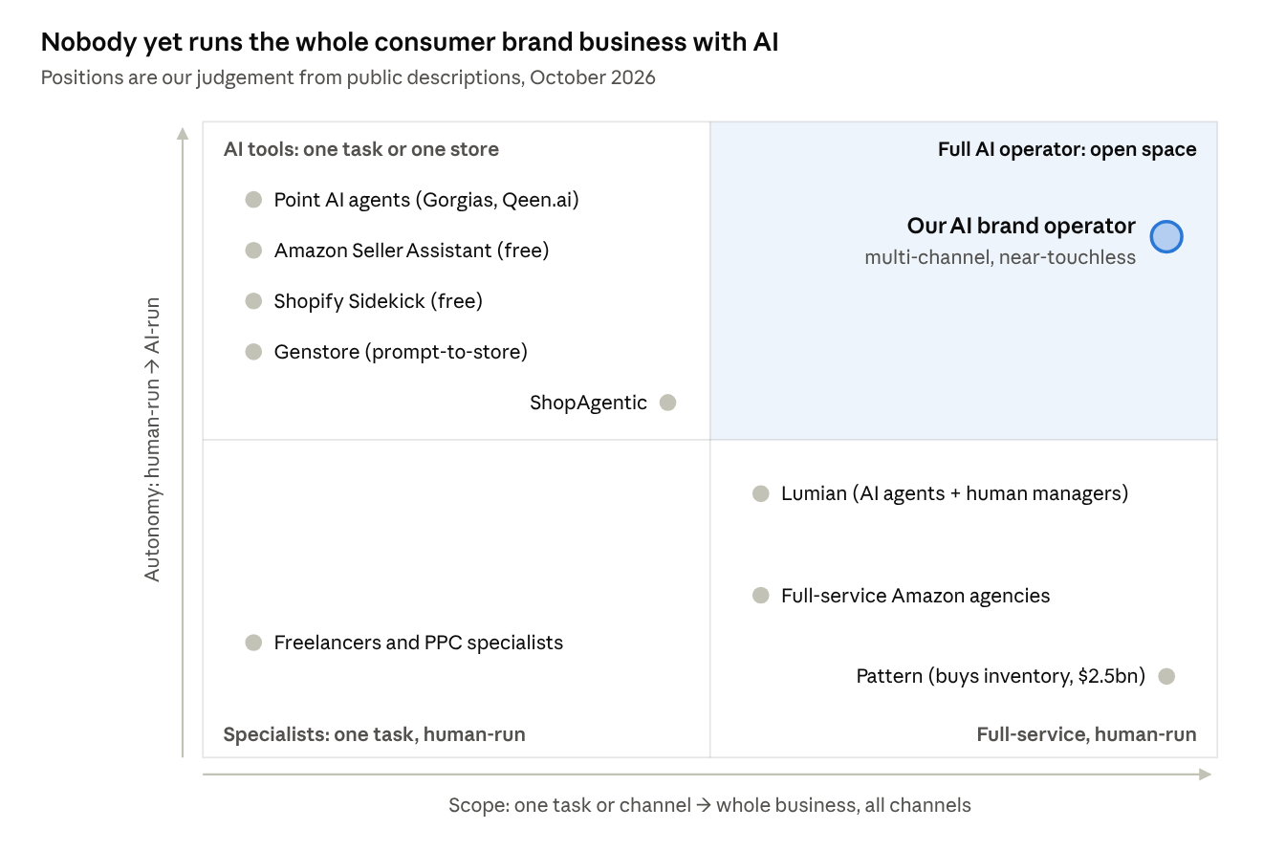
market map · scope × autonomy
Player | Model | Gap versus our concept
Pattern | Buys and resells brands' stock on 70+ marketplaces; $2.5bn revenue in 2025 | Owns stock; human-heavy; large brands
Lumian | AI-native Amazon agency; $3M seed, April 2026 | Amazon only; humans own decisions; US
ShopAgentic | Agents run catalogue, pricing, service, fulfilment; €1.9M pre-seed (Germany) | One store, not multi-channel brand operation
Amazon Seller Assistant, Shopify Sidekick | Free agents inside each platform | One channel each
Point agents (Gorgias, Qeen.ai), Genstore | One function, or DTC store launch | Narrow scope
Aggregators (Thrasio) | Bought brands, largely with debt | Chapter 11 in 2024

Key risks
Risk | Mitigation
Amazon and Shopify give single-channel agents away free | Win on cross-channel orchestration, market entry and commercial judgement; use their agents underneath
Brands won't hand over the keys | Guardrails, approval thresholds, audit log, instant pause
Full autopilot isn't ready yet | Launch as AI plus a small expert bench; drive human minutes per £ of sales down
Category regulation (supplements, cosmetics, GPSR) | Start with categories we know; automate compliance checks; partner for the EU responsible person
Part-time team against funded rivals | Agree commitments and a full-time trigger early

Wedge
Start as a market-entry autopilot for consumer health and beauty brands on UK and EU marketplaces.
- Why: a sharp, painful job; it plays to the team's expertise; the platforms' own agents don't take a brand into five countries.
- Sequence: Amazon UK, then Amazon DE, FR, IT, ES; then Shopify DTC and TikTok Shop; then more categories; then any consumer brand.
- First customers: non-EU brands entering Europe, European brands stuck in one market, corporates testing a new country, and founder-sellers who want to step back.

Business model
Priced against the agency or in-house team it replaces; exact levels to be tested.
- Onboarding fee per country or channel.
- Monthly subscription tiered by channels and countries.
- Performance fee as a % of sales, below the 3% to 15% agencies charge.
Margins should rise with each new brand as human time per brand falls. Any later investment in brands stays optional, equity-funded and separate: the Thrasio lesson.

Founding team
Founder | Brings | Likely role
Aurélien Villemonteix | International market entry and e-commerce for consumer health brands | commercial and go-to-market
VJ | CPG commercial finance (Reckitt); runs a supplement brand on Amazon | Operations and brand P&L; first pilot account
Julien Villemonteix | CEO of UpSlide, B2B SaaS; former CTO who wrote its original code | Product and technology; potential investor
The gap is a full-time AI engineering lead.

Our assessment and the critical questions
Verdict: a good idea with good timing and strong team fit. The biggest danger is trying to build the full vision at once.
- Strengths: no one owns multi-channel AI brand operation in Europe; the team covers commerce, CPG finance and SaaS; the subscription model avoids stock and debt risk.
- Concerns: "touchless" is the destination, not the launch, because brands pay for results and accountability; the customer sweet spot is narrow (roughly £1–20m brands, plus corporates testing new countries); a part-time team faces funded full-time rivals; the platforms will keep commoditising single-channel tasks.
Team workplan: 12 weeks to answer the critical questions (owners are proposals)
# | Critical question | How we answer it | Owner | Weeks
1 | Which 5 brands would pay for a pilot? | Shortlist 30 brands; 20–30 interviews; landing page with indicative prices | Aurélien, VJ | 1–4
2 | What one thing would a brand buy on its own? | Rank pain points from interviews; test market entry, ads and full operations as offers | Aurélien | 2–5
3 | Build our own agents or orchestrate existing tools? | Map each task to available tools and APIs; prototype the top 3 tasks | Julien | 2–6
4 | Do we take a performance fee and accountability for results? | Model pricing and liability scenarios; test them in pilot contracts | VJ | 3–6
5 | How much really runs without people? | Run 3–5 paid pilots concierge-style; log every human intervention | All | 5–12
6 | Is consumer health and beauty the right start? | Compare demand and compliance effort by category | VJ, Aurélien | 4–10
7 | Who goes full-time, who funds, and are employer conflicts cleared? | Agree commitments, equity, IP and funding; check permissions with current employers | All | 1–3
Decision at week 12: go (raise a pre-seed round and hire an AI engineering lead), narrow to what worked, or stop.
- ☐ Share this paper with VJ and Julien
- ☐ Hold a founders' session to agree the workplan and owners
- ☐ Start the brand shortlist and interview guide

Notes
VJ · Oct 29, 2026 · GTM scope is online plus offline, not online only. For a consumer packaged goods brand, go-to-market covers physical retail as well as digital channels, and the industry is changing fast: most retailers now want to see a product proven online, with traction, before they list it in store. So the two are sequenced, and the operator should be designed for both.
- Phase 1, digital proof of concept: establish traction on digital channels: marketplaces such as Amazon, retailers' own online platforms such as Walmart Online and Tesco Online, and D2C storefronts such as Shopify.
- Phase 2, physical expansion: use that proof to open offline retail listings. Managing the physical expansion could be handled by layering an agentic ERP build-out on top of the operator.
- Where this touches the paper: "runs its online business" in the executive summary and concept; the scope axis of the market map, which stops at all online channels; and the wedge sequence, which would gain a later step for offline retail entry.

